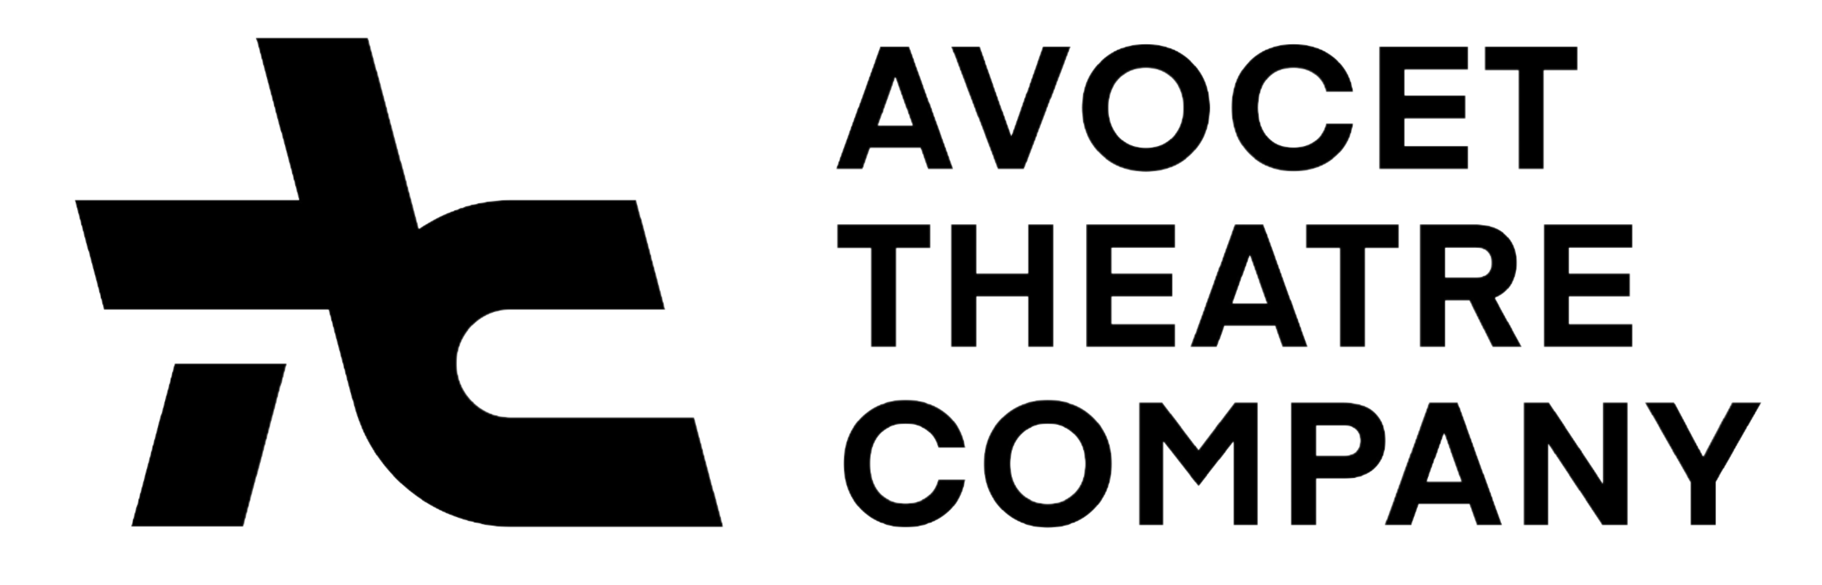

BURSARY APPLICATION

SHREK THE MUSICAL

Name of Member:

Date of Birth of Member:

Email Address:

Telephone Number:

Please write in the box below why you feel you/your child requires funding from The ATC Bursary. For example free school meals, income support, jobseekers allowance, a member of an underrepresented minority etc. Please only share what you feel comfortable sharing and know that the information provided will be treated with the strictest confidence.

(If filling out this form by hand, feel free to use the back if you need more space)

How much of the cost of this production are you hoping The ATC Bursary will cover?

How would being a member of Avocet Theatre Company benefit you/your child?

(If filling out this form by hand, feel free to use the back if you need more space)

Please note, we may contact you for more information or for supporting evidence / references

PLEASE RETURN THIS FORM PRIOR TO THE AUDITIONS TO chairman@avocettheatre.co.uk

